New Jersey Alliance for Children, Youth and Families
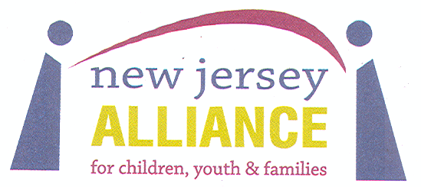
Annual Conference
Changing Conversations Changes Lives
May 23, 2018

Location: Rutgers Livingston Campus

Workshop Proposal Form

(Please fill out the following as you want it to appear on the conference brochure and program book)

Presenter Name Position/Title

Agency/Company

Phone Email

Name/Position/Title of Co-Presenter(s) Email

Audio-Visual needs:

Lunch Selection: Chicken Beef Vegetarian

Workshop Title

Intended Audience

Detailed Description of Workshop:
(Use additional space as necessary or attach your description to this form)
Please submit proposals to megann.anderson@njacyf.org by February 16, 2018

